**Batch: D - 1 Roll No.: 16010122096**

**Experiment No. 6**

|  |
| --- |
| **TITLE : To perform time series analysis on health care** |

**AIM:** To perform forecasting using time series analysis

**Expected OUTCOME of Experiment:**

CO4: Perform Time series Analytics and forecasting

**_____________________________________________________________________**

**Books/ Journals/ Websites referred:**

**_____________________________________________________________________**

**Pre Lab/ Prior Concepts:**

Students should have a basic understanding of: Time series Analytics and forecasting

**Procedure:**

**Data set Used: Hospital_patients_datasets**

**Step1: Select and Load the dataset**

**Step2: Convert 'ScheduledDay' and 'AppointmentDay' to datetime format**

**Step 3: Forecasting Daily Attendance**

**Step4: Initialize Prophet model for forecasting**

**Step 5: Fit the model**

**Step 6: Predict future attendance**

**Step 7: Plot the forecast**

**Step 8: Exploratory Data Analysis Functions**

**Step 9: Running the analysis functions**

Implementation details:

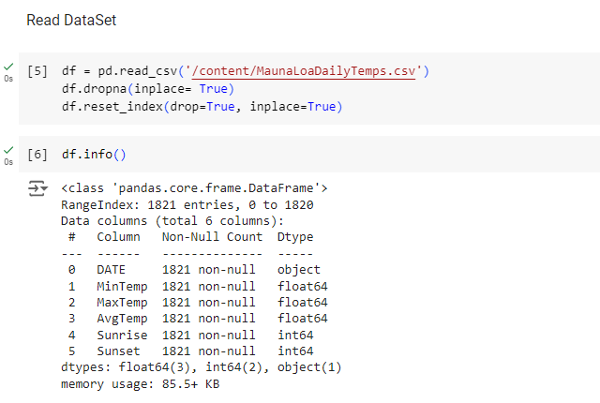

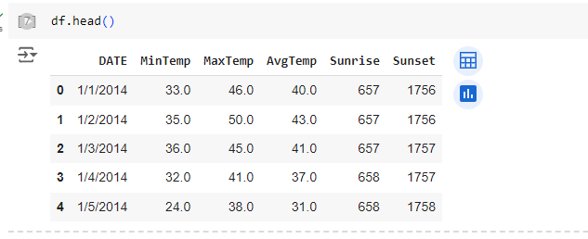

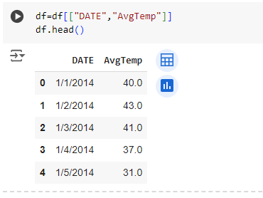

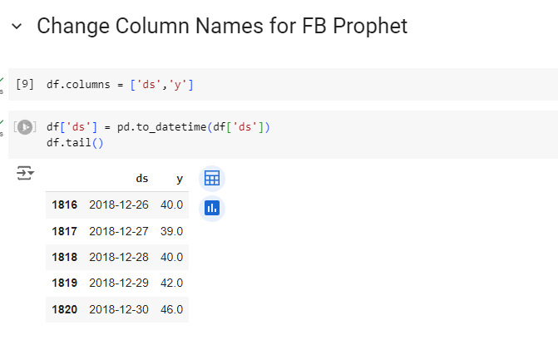

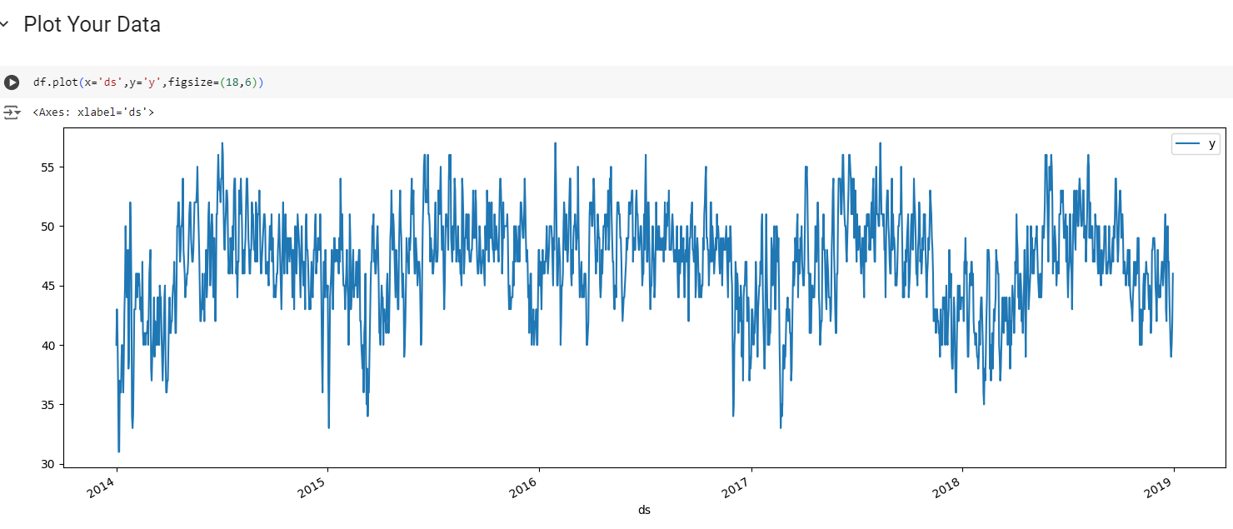

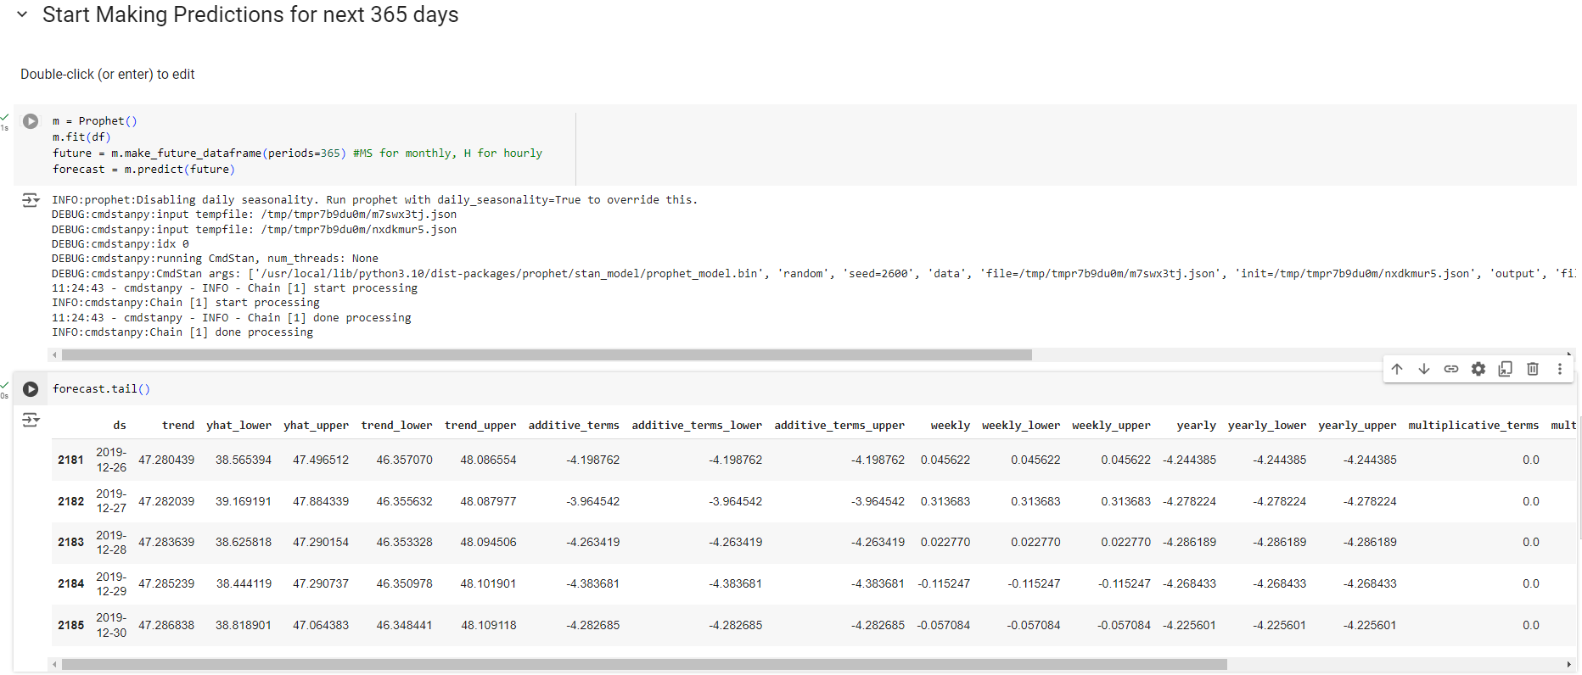

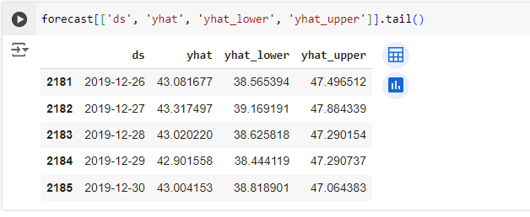

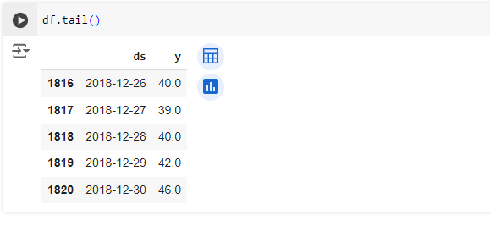

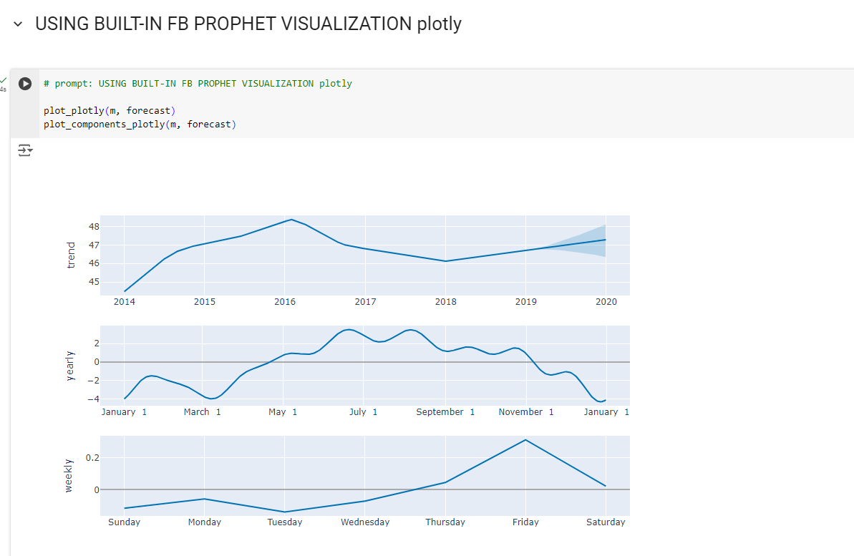

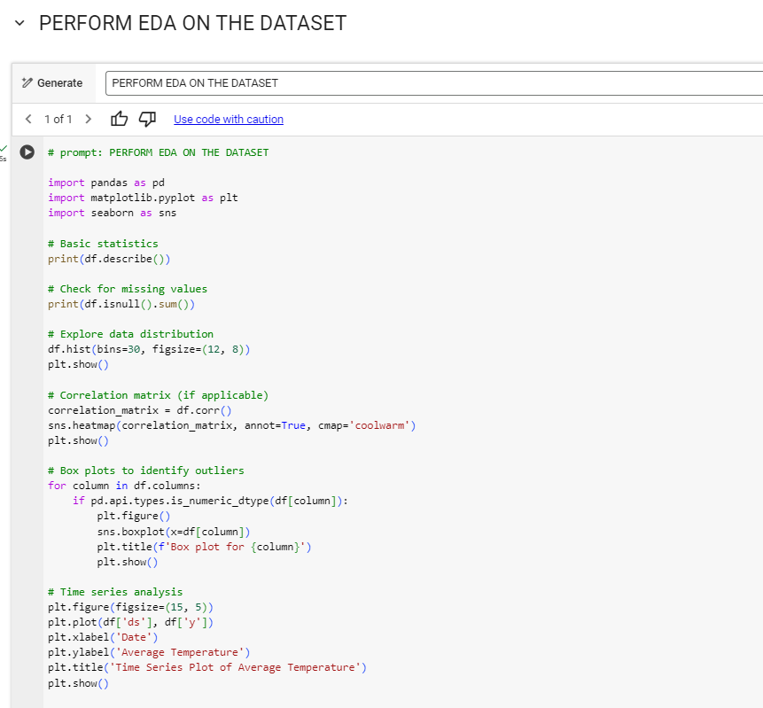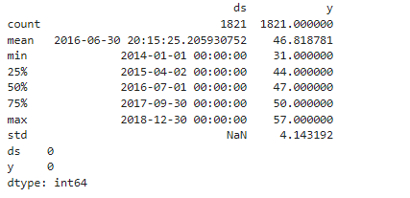

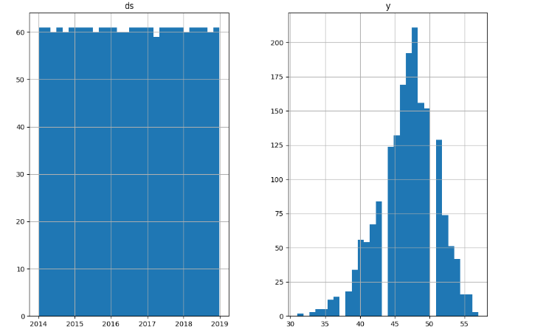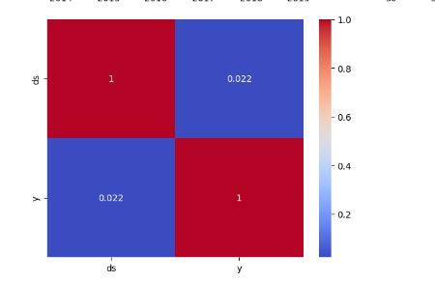

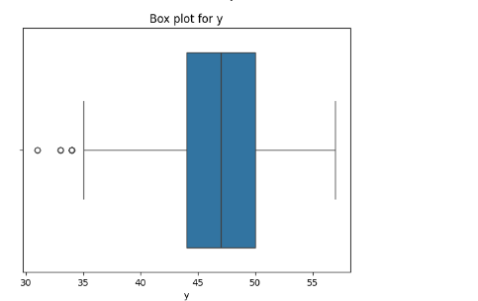

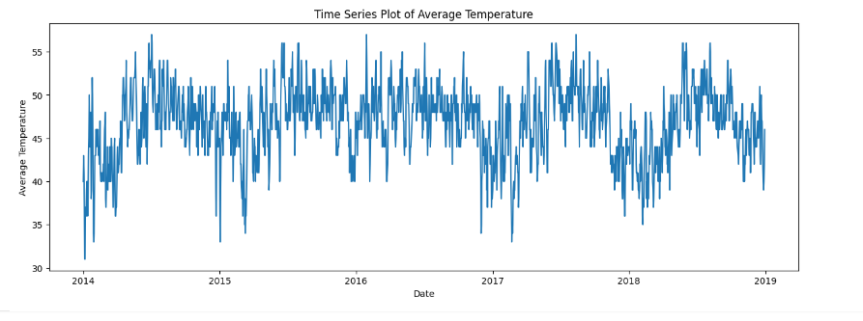

**Date: _____________ Signature of faculty in-charge**

**Post Lab Descriptive Questions:**

1. Explain the components of time series?

A time series typically consists of four main components:

* **Trend:** This represents the long-term movement in the data. It shows the overall direction (increasing, decreasing, or constant) over time.
* **Seasonality:** This refers to the regular, periodic fluctuations that occur at specific intervals, such as daily, monthly, or yearly. These patterns are often influenced by external factors, such as holidays or seasons.
* **Cyclic Patterns:** Unlike seasonality, cyclic patterns occur over irregular intervals and are influenced by economic or other factors. They reflect long-term economic cycles and can last for several years.
* **Irregular (or Noise):** This component captures random variations or noise in the data that cannot be attributed to trend, seasonality, or cyclic behavior. It often represents unforeseen events or outliers.

1. How do you handle seasonality in time series data? What methods or transformations can you apply?

There are several methods to address seasonality in time series data:

* **Seasonal Decomposition:** This method involves decomposing the time series into its trend, seasonal, and residual components (e.g., using Seasonal-Trend decomposition using LOESS - STL).
* **Differencing:** Seasonal differencing can help remove seasonal patterns. For instance, subtracting the value from the same season in the previous year (e.g., yt−yt−sy_t - y_{t-s}yt​−yt−s​, where sss is the seasonality period).
* **Fourier Transformations:** These can be applied to model seasonality by capturing periodic fluctuations, useful in more complex seasonal patterns.
* **Dummy Variables:** Creating dummy variables for seasonal periods can also help incorporate seasonality in regression-based models.
* **Using Seasonal Models:** Models like SARIMA (Seasonal ARIMA) and Holt-Winters Exponential Smoothing explicitly account for seasonality.

1. What are some common metrics for evaluating forecasting models (e.g., MAE, RMSE, MAPE)?

There are several key metrics used to evaluate the performance of forecasting models:

* **Mean Absolute Error (MAE):** This measures the average magnitude of the errors in a set of forecasts, without considering their direction. It is calculated as:

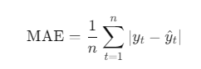

* **Root Mean Squared Error (RMSE):** This measures the square root of the average of squared differences between predicted and actual values. It gives a higher weight to larger errors:

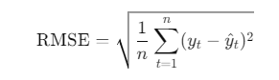

* **Mean Absolute Percentage Error (MAPE):** This metric expresses the error as a percentage of the actual values, making it easy to interpret:

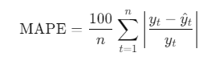

Each of these metrics has its strengths and weaknesses, and the choice of metric may depend on the specific context of the forecasting task.